**HOLY TRINITY CHURCH FUNCHAL** Rua da Quebra Costas 20

THEMED MEAL AND FILM REVIEW SEPTEMBER 27th 6.30p.m.

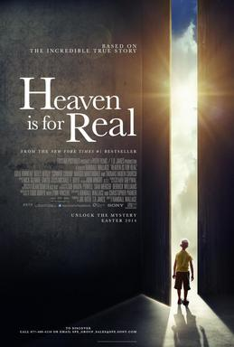

The film follows the story of Colton Burpo, a four year old boy who udergoes surgery for appendicitis.During the operation he slips into a coma and claims to have visited Heaven.

**MENU: Heavenly Chicken Picatta**

**( lemon chicken on a bed of spagetti and mixed vegetables)**

**Amazing Fruit Gateau and cream**

**Tickets on night 17.50 euros**

PLEASE BOOK with Jean ([friendssecretaryhtc@outlook.com](mailto:friendssecretaryhtc@outlook.com)) by 24th September 2025