HOLY TRINITY CHURCH FUNCHAL Rua da Quebra Costas 20
THEMED MEAL AND FILM REVIEW APRIL 23rd 2026 at 6.30p.m.
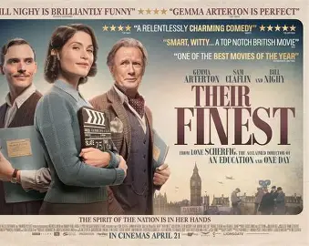

Their Finest is a 2016 British war comedy-drama It tells the story of a British Ministry of Information film team making a morale-boosting film about the Dunkirk evacuation during the Battle of Britain and the London Blitz. Menu Cottage pie and broccoli Bread and butter pudding
Tickets on night 20 euros each PLEASE BOOK by 20th April with Jean at (friendssecretaryhtc@outlook.com) .

