HOLY TRINITY CHURCH
RUA QUEBRA COSTAS 20 FUNCHAL
With Penha da franca chapel

EASTER COLLECTION
Toiletries, dried/ tinned food, toys /gifts,easter eggs

PLEASE ADD A FEW ITEMS TO YOUR SHOPPING AND BRING THEM ALONG TO CHURCH ON SUNDAYS BEFORE EASTER TO HELP THOSE WHO HAVE LITTLE at this special time
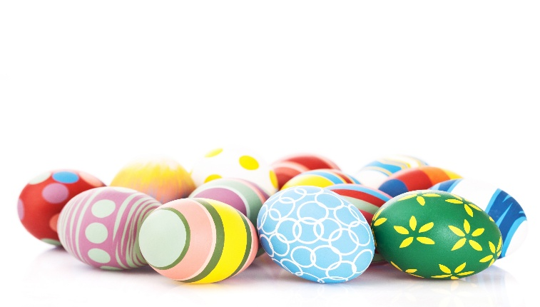
Put in box at back of church or see jean Faulkner (965733057)

