HOLY TRINITY CHURCH FUNCHAL
Rua da Carreira 20
SATURDAY 23rd May 2026 6.30p.m.
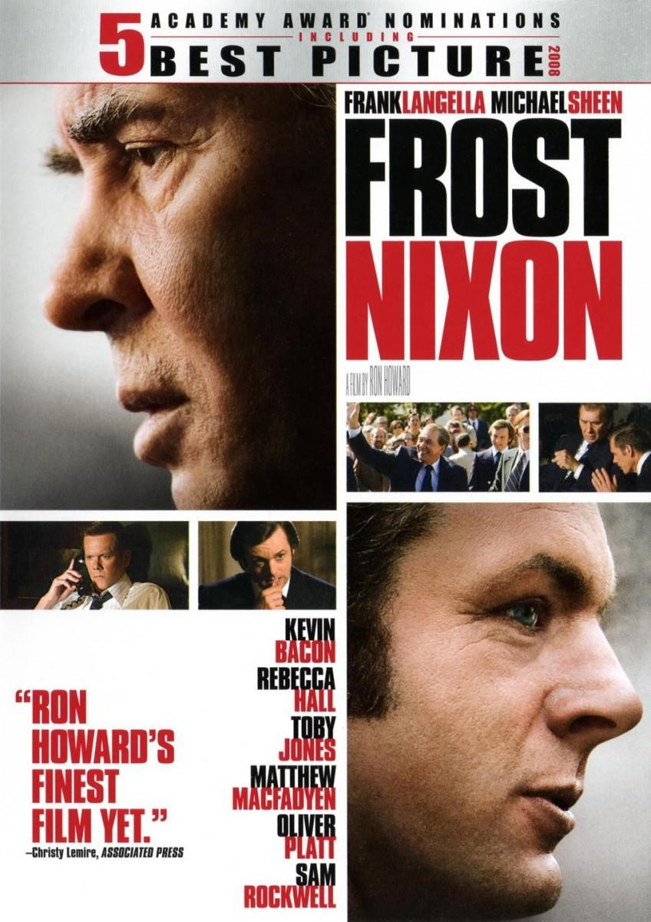

.

"Frost/Nixon" is a 2008 historical drama directed by Ron Howard, depicting the 1977 televised interviews between David Frost and former U.S. President Richard Nixon.
MENU: Steak pie. mashed potatoes, mixed vegetables Ice cream sundaes
PLEASE BOOK by20th Tickets on night 20 euros each
with Jean at (friendssecretaryhtc@outlook.com) .

